HARROW COUNCIL

SUPPLEMENTAL ADDENDUM

PLANNING COMMITTEE

DATE: 19th April 2023

2/03 | Rooks Heath College, Eastcote Lane, South Harrow, HA2 9AH  Swept path drawings have now been submitted.  Remove the below stricken through bold text within the ‘REASON FOR THE RECOMMENDATION’ section.  The proposal would result in an improvement in the school’s educational facilities whilst ensuring that the proposed building would not detract from the character and appearance of the application site, street scene and area in a wider context, and would have an acceptable impact upon the residential amenity of neighbouring properties. The replacement building would be appropriately accessible for both able-bodied and disabled users. The development’s provision of car and cycle parking is acceptable, and compliance with the submitted travel plan ensures that there would be sustainable travel by students, staff and visitors to the school. The development is not considered to be susceptible to harmful flooding and is not considered to exacerbate flood risk elsewhere. Insufficient detail has been provided on the development’s compliance with Secured by Design and fire safety requirements, additional detail on this can be requested and secured via conditions, a condition has also been applied requiring the applicant to submit a Construction Logistics Plan given the scale of the development and demolition works required. The Council’s Transport Officer has requested Swept Path Analysis drawings to demonstrate that proposed replacement car parking spaces can be safely accessed, this has been requested and will be provided as part of an addendum. In light of the above, subject to conditions and the provision of swept path drawings, the proposed development would be in accordance with the National Planning Policy Framework (2021), Policies GG1, GG2, GG3, D3, D4, D5, D11, D12, D13, D14, S1, S3, SI 12, SI 13, T1, T2, T3, T4, T5, T6, T7 of the London Plan (2021), Policies CS1.B, CS1.E, CS1.T, CS1.U, CS1.W, CS1.Z, of the Harrow Core Strategy, Policies DM1, DM2, DM9, DM10, DM12, DM14, DM22, DM42, DM43, DM44, DM46 of the Harrow Development Management Policies Local Plan.  Update Paragraph 2.3 as follows:  New sheltered and secure cycle parking is to be provided as part of the development. This consists of; 20 visitor/staff cycle parking spaces to the front of the site (with a 50/50 split), 2x 40 student cycle parking spaces beside the area of the demolished building, 20 staff cycle parking spaces further north of this, and a further 40 student cycle parking spaces slightly to the north east of this. There would be a total of 120 student cycle parking spaces, 30 staff cycle parking spaces, and 10 visitor cycle parking spaces with a grand total of 160 proposed cycle parking spaces.  Update paragraph 2.6 under the second bullet point to include:-  - The applicant has provided swept path drawings detailing vehicular access to the proposed replacement parking spaces within and beside the area of the existing building being demolished.  Update the consultation response from the Highways Authority in the table under paragraph 4.5:-  Highways Authority – Requested for the applicant to provide a Parking Assessment and School Travel Plan and initially had concern that the development’s resulting loss of car parking for staff would result in an unacceptable overspill to surrounding roads. Requested for the school to provide cycle parking in line with London Plan minimum standards. Requested for swept path drawings to indicate that the proposed replacement parking spaces can be safely accessed. Requested for the applicant to provide a Construction Logistics Plan. Following amendments to the scheme and the provision of replacement car parking, proposed cycle parking provision, an updated Parking Assessment, Travel Plan and swept path drawings, the Highways Officer has confirmed that they are satisfied with the proposal. They have however indicated that insufficient information is provided within the submitted Construction Logistics Plan noting various areas where further information is required.  Update the consultation response to include the following:-  Environmental Health Officer – Confirmed that the information provided within the submitted Construction Logistics Plan appears acceptable, and raised no objection to the proposal.  Update Paragraph 6.6.7 as follows:-  There has been extensive communication between the applicant and the Council’s Highways Authority, who in spite of their initial concerns in regards to overspill car parking to surrounding roads has confirmed that they do not raise objection to the development following amendments made to proposed car parking and through the provision of cycle parking. The proposal would only result in a net loss of 2.no car parking spaces, the development’s provision of a high quantum of cycle parking and other initiatives for sustainable travel outlined within the School Travel Plan are considered to make up for the loss. The applicant has provided swept path drawings to demonstrate that the proposed replacement car parking spaces can be safely accessed, the Council’s Highways Officer has confirmed that the development would be acceptable in this regard. The applicant has submitted a Construction Logistics Plan, however the Council’s Highways Officer has confirmed that insufficient information has been provided within this document, the Council have consequently applied a condition requiring the applicant to submit a revised Construction Logistics Plan. The application site currently provides 20 existing cycle parking spaces on site, the applicant is proposing an additional 160 cycle parking spaces. The London Plan minimum cycle parking standards set out that schools will be required to provide a minimum of 1.no long stay space for 8 full time staff and 1.no long stay spaces for every 8 students. 1.no short stay space is expected for every 100 students, The Council’s Transport Officer has reviewed the total number of cycle parking spaces provided for the development and has raised no objection.  Add in the word ‘Revised’ where indicated in bold below and remove the stricken through bold text within Paragraph 7.1  The proposal would result in an improvement in the school’s educational facilities whilst ensuring that the proposed building would not detract from the character and appearance of the application site, street scene and area in a wider context, and would have an acceptable impact upon the residential amenity of neighbouring properties. The replacement building would be appropriately accessible for both able-bodied and disabled users. The development’s provision of car and cycle parking is acceptable, and compliance with the submitted travel plan ensures that there would be sustainable travel by students, staff and visitors to the school. The development is not considered to be susceptible to harmful flooding and is not considered to exacerbate flood risk elsewhere. Insufficient detail has been provided on the development’s compliance with Secured by Design and fire safety requirements, additional detail on this can be requested and secured via conditions, a condition has also been applied requiring the applicant to submit a revised Construction Logistics Plan given the scale of the development and demolition works required. The Council’s Transport Officer has requested swept path drawings to demonstrate that proposed replacement car parking spaces can be safely accessed, this has been requested and will be provided as part of an addendum.  Amend Condition No. 2 (Approved Plans and Documents)  The development hereby permitted shall be carried out in accordance with the following documents and plans: Design and Access Statement, 0655-011 (Existing Floor Plans and Elevations), 0655-012 (Proposed Floor Plans and Elevations), 0655-014 Rev A (Swept Path Car Parking Strategy), Parking Assessment Dated March 2023 (Report Ref. 2204780-02A), School Travel Plan Dated March 2023 (Report Ref. 2204780-01B), BDS Cycle Shelter – 20 Space Shelter & Bike Stands (Produced by Bikedock Solutions), BDS Shelter – 40 Space Enclosure & Bike Stands (Produced by Bikedock Solutions), Email from Agent (Dated 06/03/2023), Email from Agent (Dated 13/04/2023), Demolition and Construction Logistics Plan.  REASON: For the avoidance of doubt and in the interests of proper planning.  Amend Condition No. 5 (Construction Logistics Plan)  No development shall take place, including any works of demolition, until a revised demolition and construction logistics plan has first been submitted to the Local Planning Authority and agreed in writing. The plan shall detail the arrangements for:  a) the parking of vehicles of site operatives and visitors;  b) loading and unloading of plant and materials;  c) storage of plant and materials used in construction the development;  d) the erection and maintenance of security hoardings including decorative displays and facilities for public viewing;  e) wheel washing facilities; and  f) a scheme for recycling/disposing of waste resulting from demolition and construction works.  g) measures for the control and reduction of dust  h) measures for the control and reduction of noise and vibration  i) How traffic would be managed to minimise disruption  j) Air quality management measures  The demolition and construction of the development shall be carried out in accordance with the plan so agreed.  REASON: To ensure that measures are put in place to manage and reduce noise and vibration impacts during demolition and construction and to safeguard the amenity of neighbouring occupiers, and to ensure that the transport network impact of demolition and construction work associated with the development is managed. To ensure that measures are agreed and in place to manage and reduce dust, noise and vibration during the demolition and construction phases of the development and manage transport impacts during the demolition and construction phases of the development. This condition is a PRE-COMMENCEMENT condition as the proposed measures must be in place prior to commencement of works.  Amend Condition No. 6 (Parking Arrangements)  Prior to the construction of the new building, the temporary car parking spaces detailed on Drawing No. 0655-014 Rev A (Swept Path Car Parking Strategy) shall be made available. The proposed building shall not be first occupied until the existing teaching building identified to be demolished has been removed and the proposed car and cycle parking to be sited in place of this has been fully installed.  REASON: To ensure that there is sufficient on-site parking throughout all stages of the development  Amend Condition No. 7 (Cycle Storage)  Other than when in use, cycles shall be stored at all times within the designated cycle stores detailed on Drawing No. 0655-014 Rev A (Swept Path Car Parking Strategy).  REASON: To enhance the appearance of the development and safeguard the character and appearance of the area.  Add in 9th Informative noting the following:  The Car Parking Strategy drawing (0655-013 Rev B) included within Appendix A of the School Travel Plan Dated March 2023 (Report Ref. 2204780-01B) has been updated by Drawing No. 0655-014 Rev A (Swept Path Car Parking Strategy). Despite being included within the Travel Plan, the applicant is advised that Drawing No. 0655-013 Rev B (0655-013 Rev B) has not been approved as part of this application.  Within Appendix 3 substitute the Proposed Site Plan with the following drawing:  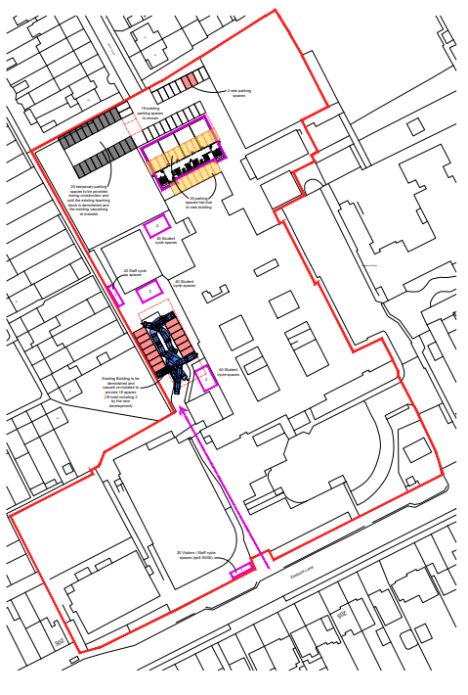  Within Appendix 3 include the following swept path drawings following the ‘Proposed Site Plan’  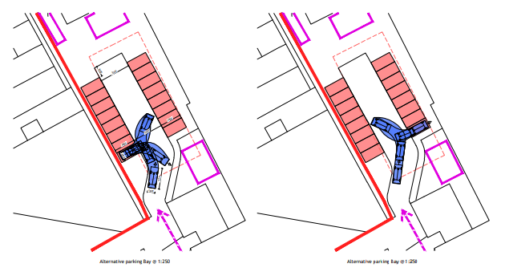  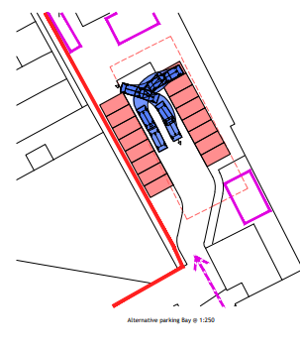
2/04 | Vaughan Library, High Street, Harrow, HA1 3HT  Update photo on page 186 to be as follows, as per the extract from the Design and Access Statement which includes a note:  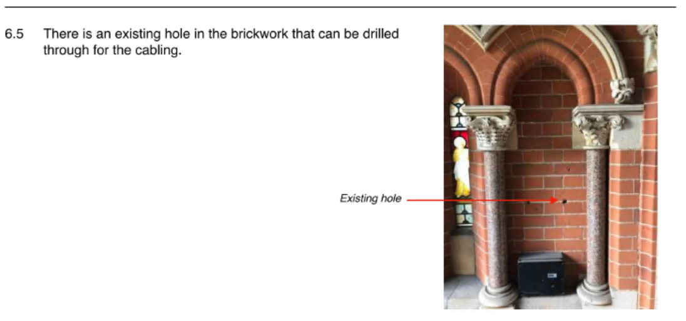
Quarterly (Calendar Year) Appeals Report

Alter the below stricken through bold text within the first page/item/table, (“1, 3 and 5 Bacon Lane and Kilbys Industrial Estate, Bacon Lane, HA8 5AS”), underneath the tab entitled ‘Decision Type’ to now read:

Committee Refusal Overturn on 19.01.2022

AGENDA ITEM 10 – REPRESENTATIONS ON PLANNING APPLICATIONS

NONE NOTIFIED

